Lab – Preparing Server 2019 for Promotion to a Domain Controller

Overview

In this lab, you will learn how to prepare Server 2019 for promotion to a domain controller. The method demonstrated in this lab is the same method used in the real world to quickly get a domain controller up and running with as few steps as possible.

Requirements

One freshly installed virtual machine is running Server 2019 with GUI.

Log in to the machine locally as administrator.

Begin the lab!

Setting a static IP address

Click on the Server 2019 start button. Click on the Search icon (1), in the search box type CMD for command prompt (2). From the results select Command Prompt (3).

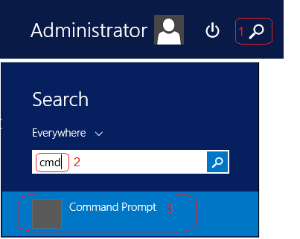

Once the command prompt opens, at the prompt type IPCONFIG. Find your IPv4 address and either remember it or write it down. (You can leave the prompt open if you like)

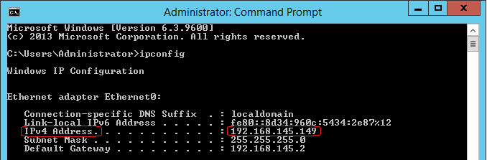

This is my IPv4 IP address! Your IP address will differ.

Scroll to the bottom right of your Server 2019 toolbar and find the network icon (1). Right-click and from the context menu select Open Network and Sharing Center (2).

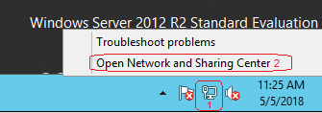

On the Network and Sharing Center screen, from the left menu, 2x click, Change adapter settings.

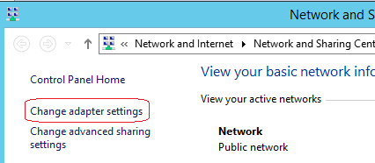

Under network connections, find your Ethernet0 or local area network adapter. This is the network adapter assigned to your Server 2019 virtual machine. Right-click on the adapter and select properties.

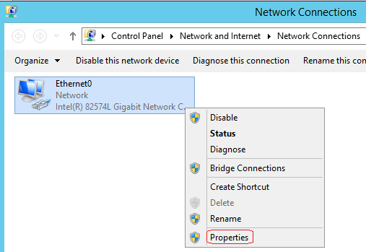

On the adapter’s properties page, from the listed items, select Internet Protocol Version 4 (TCP/IPv4) and either double-click the item or highlight and select the properties button.

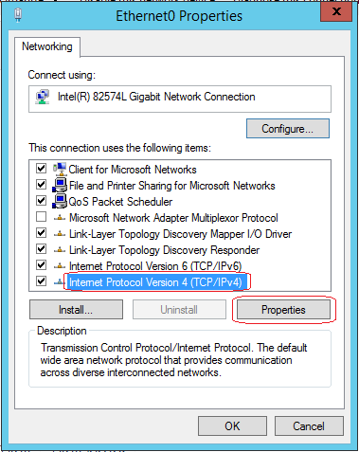

On the properties paid for your Internet protocol version 4, select the radio button for, “Use the following IP address.”

In the IP address box type the IPv4 address you discovered using the IPCONFIG command earlier in the lab.

Just click inside of the subnet mask box, and Windows will fill in the subnet mask information automatically.

For the default gateway, use the same IPv4 address you typed into the IP address field. For your preferred DNS server address, since this machine will be hosting DNS and DHCP, we do not want to register with itself. To do this, we tell the machine to look locally for any DNS or DHCP records by using the machines loopback address. In the preferred DNS block, type 127.0.0.1.

We could leave the preferred DNS block and empty, and when we install DNS, the loopback address will automatically be configured. Leaving the block empty generates a warning when DNS is installed which may be confusing for those new to server 2019.

Once you have all the information correctly filled in for the TCP/IP version for properties, click on the okay button. The machine is now statically configured with an IP address.

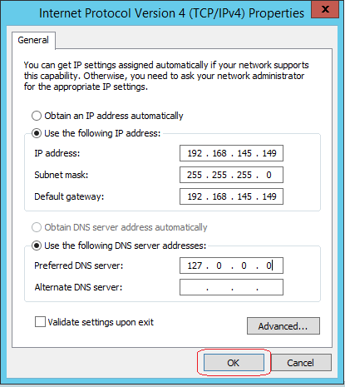

If you’re prompted to restart, go and restart your machine and come back up and log in as administrator.

Changing the name of the Server

The next thing we need to do is change the name of the server to something more useful and administratively friendly.

Click on the start button and again select the search icon. In the search field, type, system. From the list of results click on system.

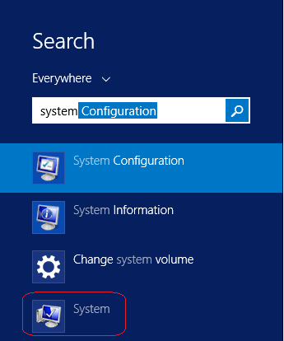

Once the system property page opens, under the computer name, domain, and workgroup settings you can find the default name assigned to the server. To the right, click on the link that says, Change settings.

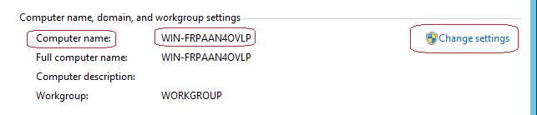

On the next system properties window, click on the change button.

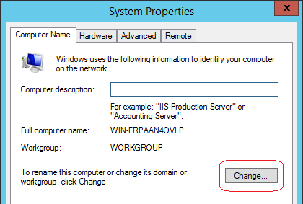

In the computer name field, type in an administratively and user-friendly name for this server. Since this machine will be promoted to a domain controller, there should be something in the name that tells the user, that the machine is running active directory and is a domain controller for the domain. In this example, I am going to change the name of this machine to DC1. Your naming convention may differ, and that’s fine. If later, you decide to change the name again just follow the same procedure as outlined in this lab. In server 2012, you can change the name of a domain controller running active directory.

This is the procedure for renaming any machine running a Windows operating system.

Click OK, and you will be prompted to restart the machine before the changes take effect.

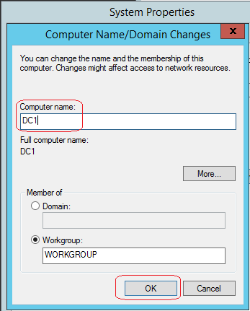

When you close out, the system properties, you will ask to restart.

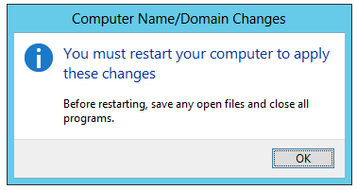

Once you close out the system properties, you will be asked to restart your machine before the changes take effect.

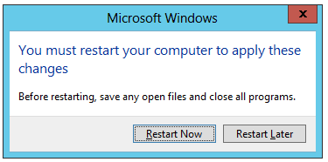

After the start and you log back on administer, you can see the name change in Server Manager under Local Server.

Summary

Properly preparing a machine for inclusion in the domain is an important step in reducing the administrative burden of trying to keep track of a large and varying number of machines. We can name a machine based on one of the following three or all three criteria.

1. Windows version

2. Windows type

3. Function.

In this lab, I used the name DC1. This tells the administrator that this is a domain controller, it is the first DC in the forest, and it is the root DC.

If this were a Windows 7 machine, I might have renamed the machine starting with the type, Win7. I next might include where it is located, or its function. Win7-HR and finally labeled it with an identifying number to help locate it in the HR department. The final name reads, Win7-HR01.

Why We Statically Configure the IP Address

Machines and devices that need to be constantly available on the network need to be statically configured for IP addressing. These include domain, controllers, file servers, routers, switches, firewalls, and web servers just to name a few. We do not want these devices using DHCP as their locations will change making them unavailable to end users.

End of the lab!